**INTRODUCTION**

* 1. ***Overview***

Analysing housing prices in metropolitan areas of India involves studying various factors

Like location, property type, market trends, and economic conditions. Researchers often collect and analyse data on property sales, square footage, amenities, and local infrastructure

Development to understand price dynamics. Additionally, demographic factors, such as population growth and income levels, can influence housing demand and prices. Advanced

Techniques like regression analysis and data visualization can help identify patterns and make

Predictions about future price trends in these areas.

* 1. Purpose

The purpose of analysing housing prices in metropolitan areas of India is to understand

Why and how the prices of homes and properties change over time. This analysis helps individuals, investors, and policymakers, make informed decisions about buying, selling, or investing in real estate in these urban regions.

**Problem Definition & Design Thinking**

***2.1 Empathy Map***



***2.2 Ideation & Brainstorming Map***



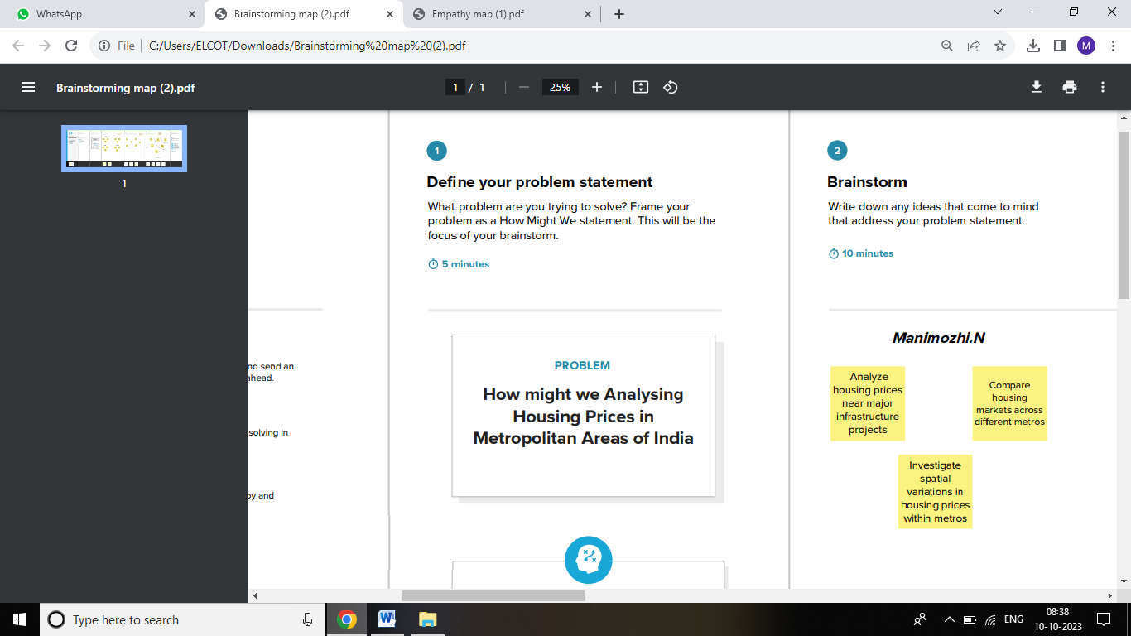

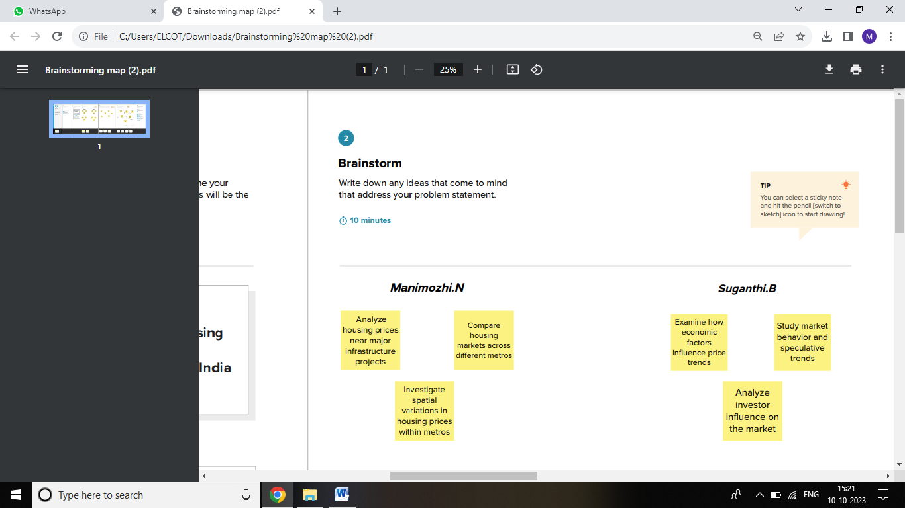

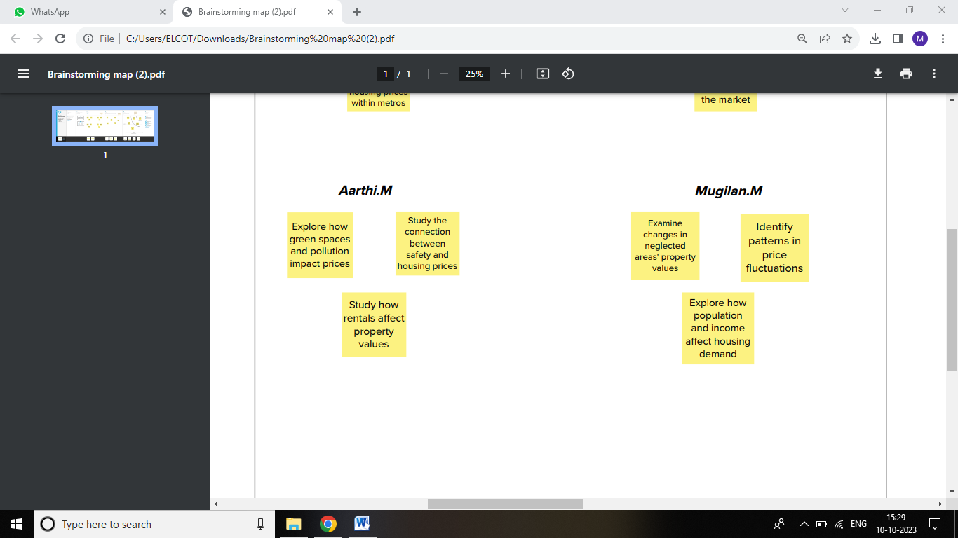



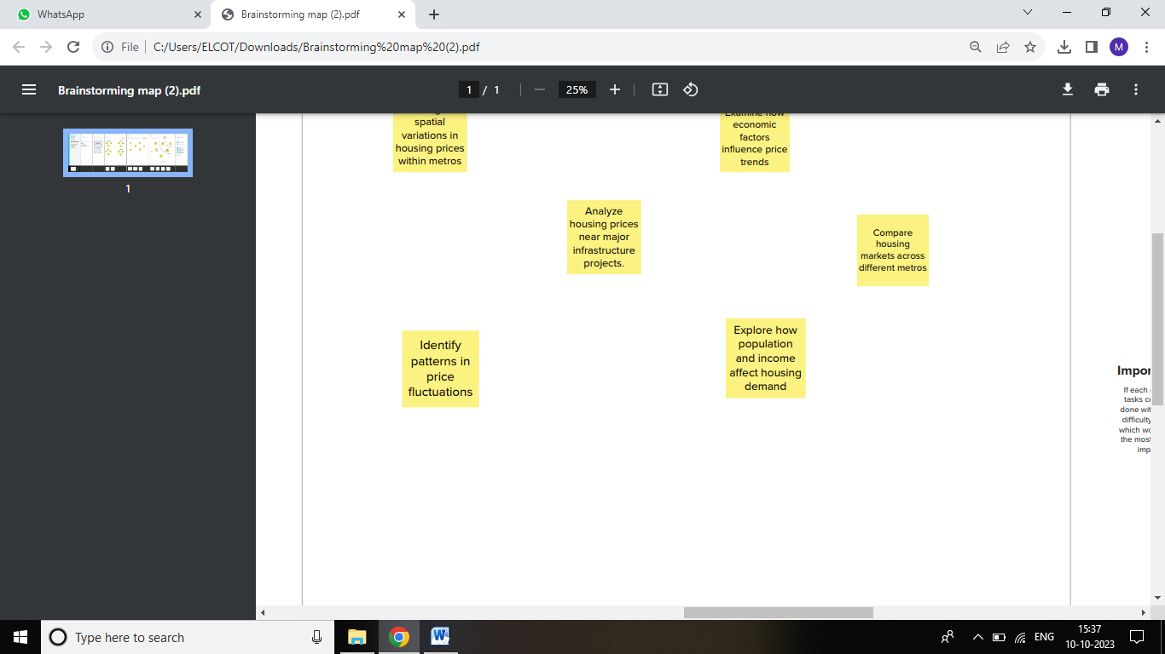

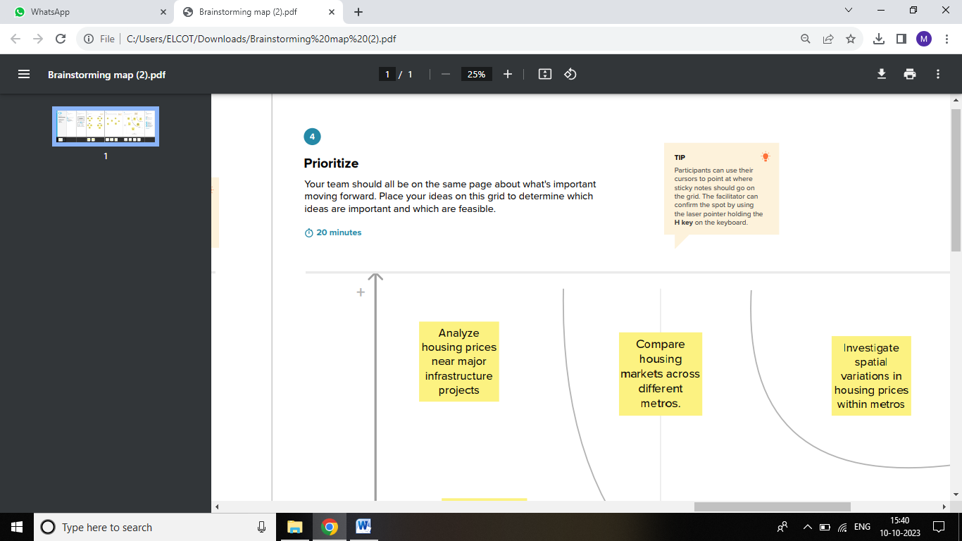

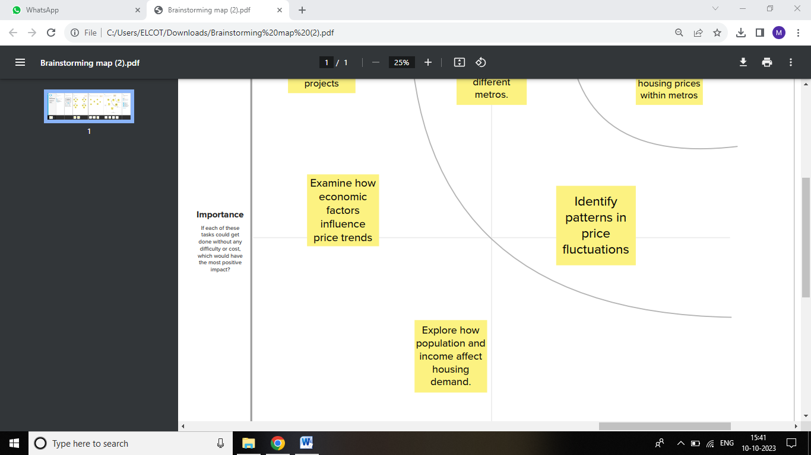

Result

*Dashboard & Story*

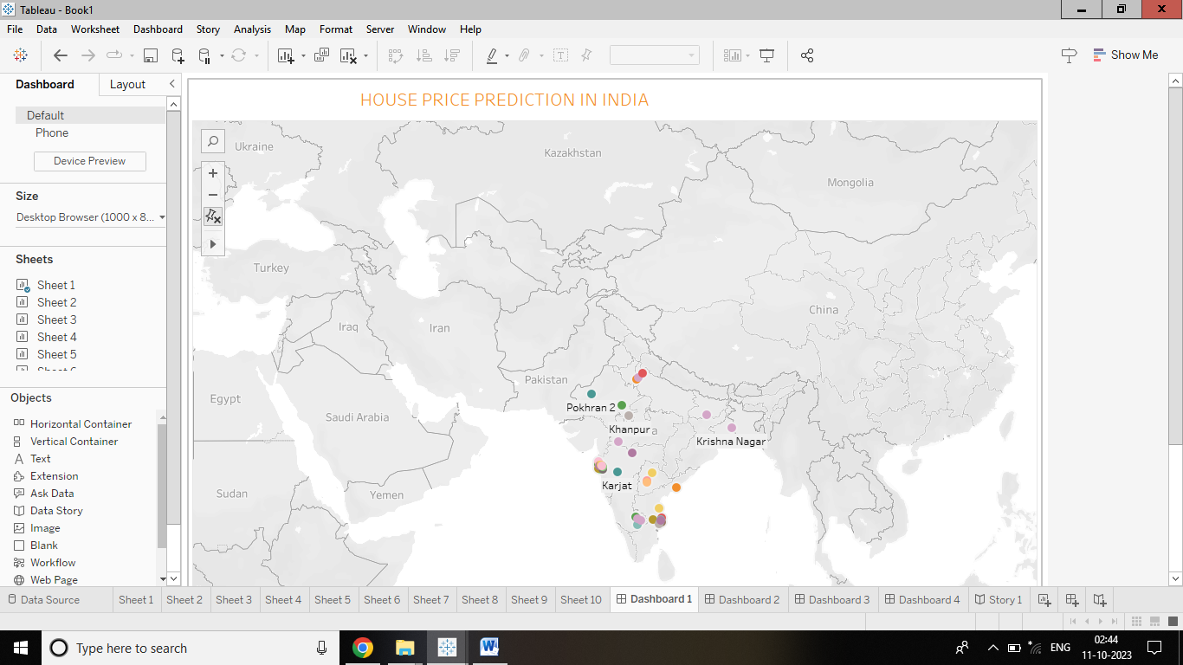

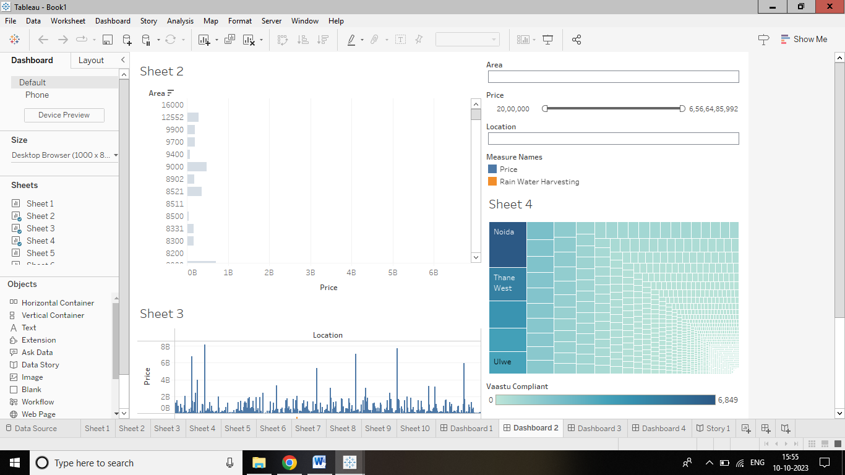

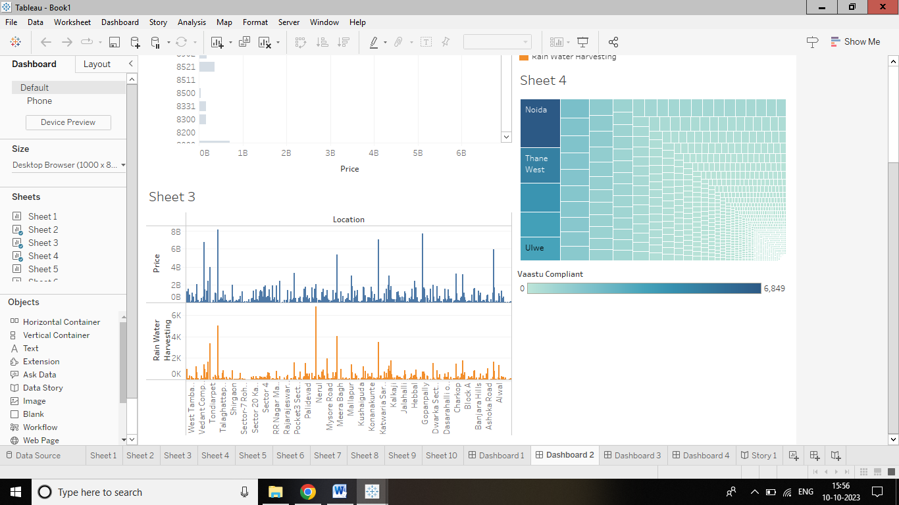

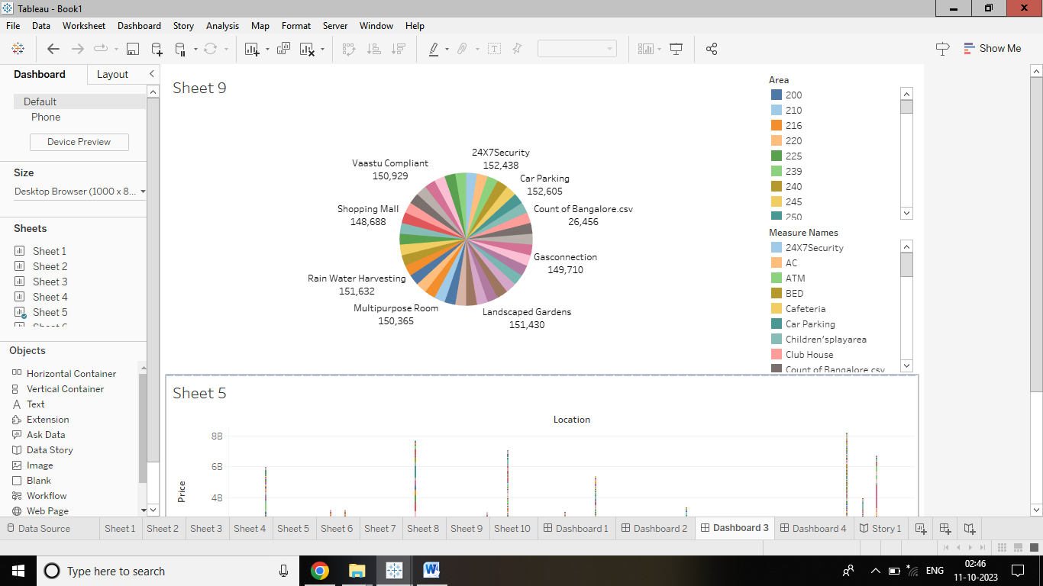

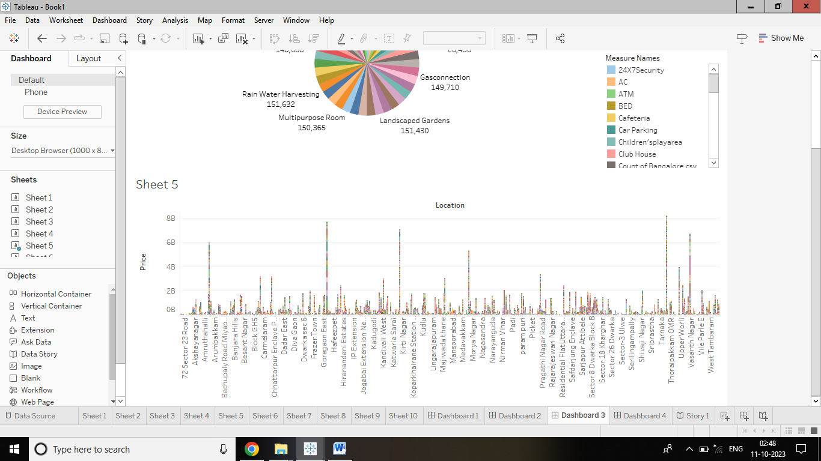

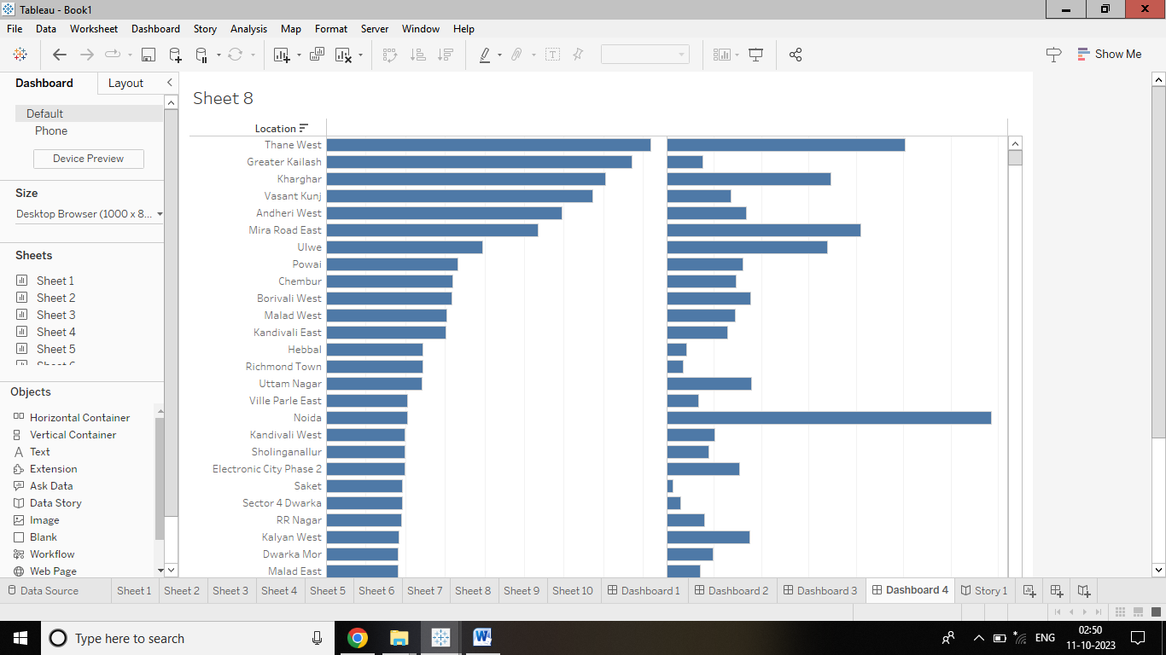

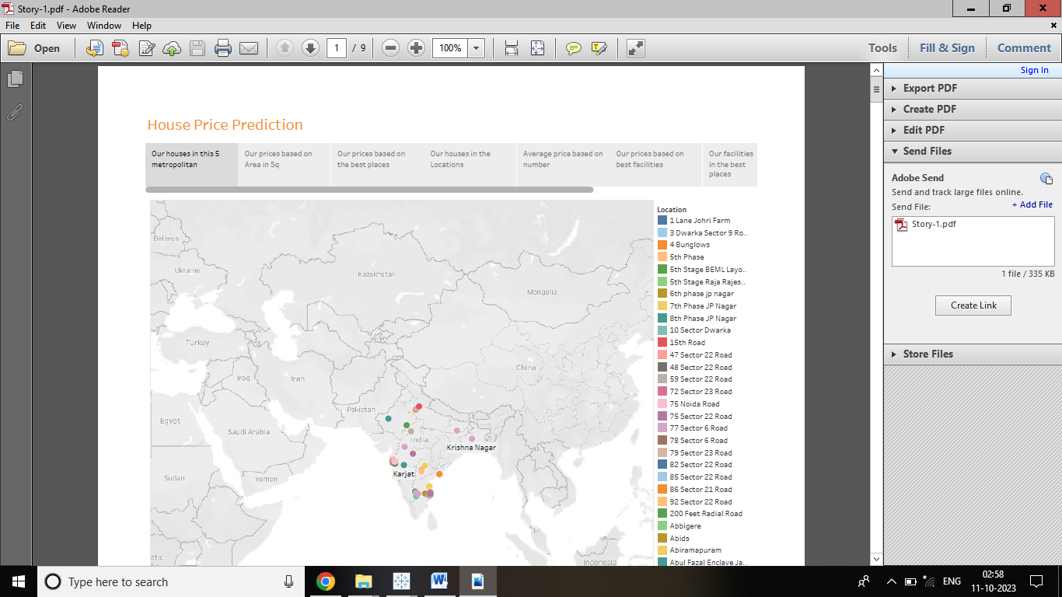

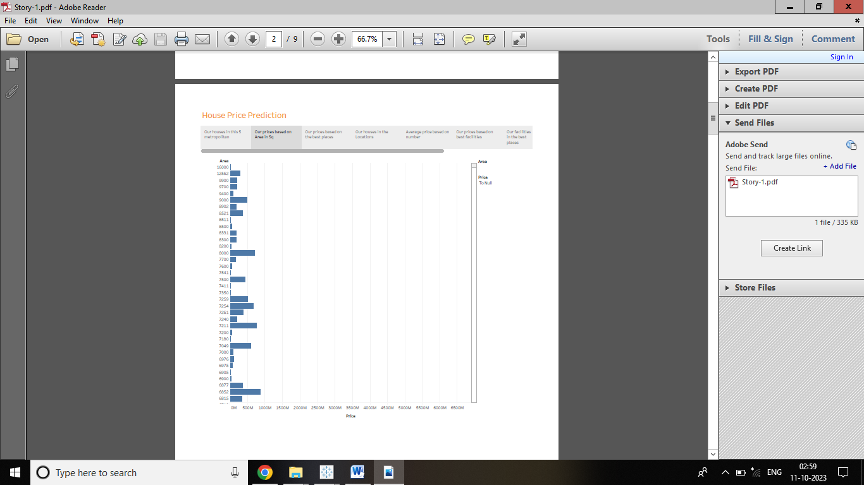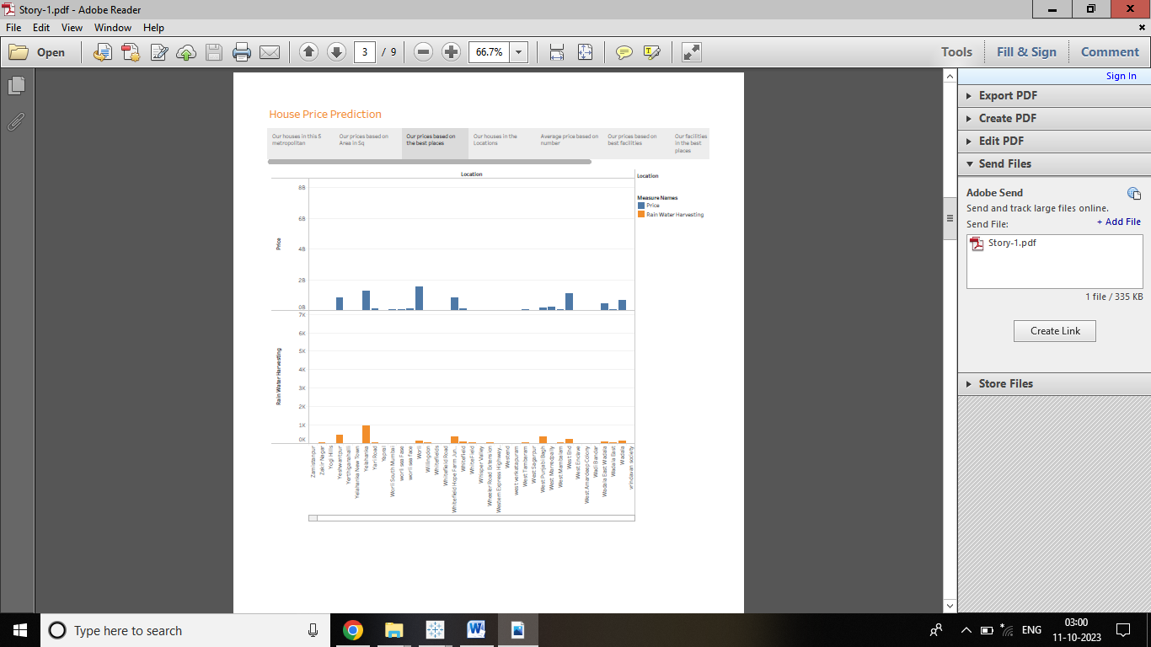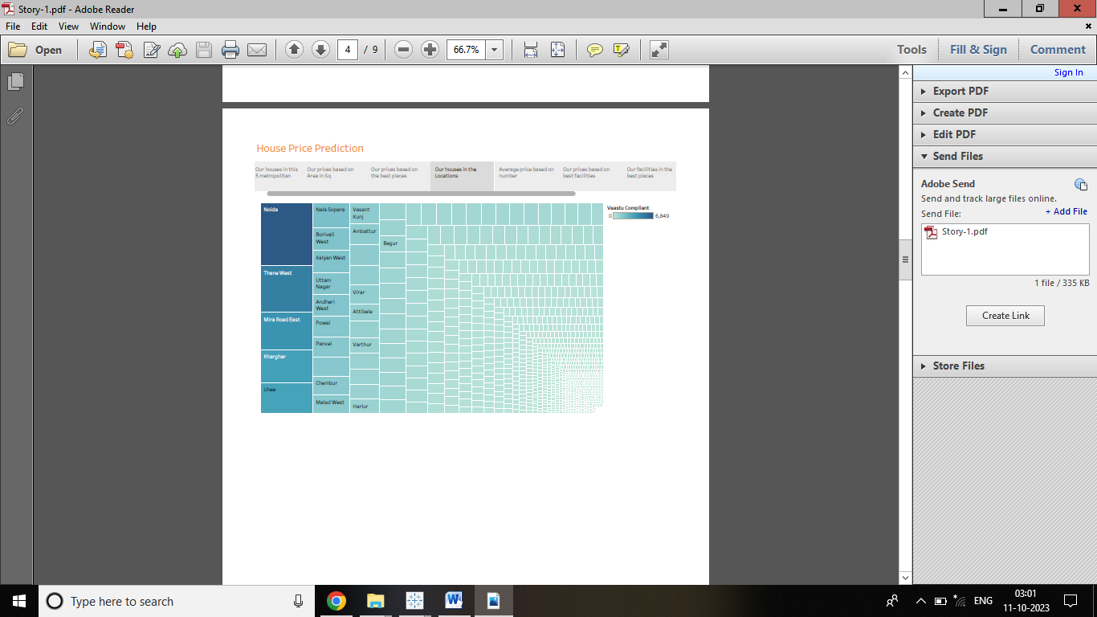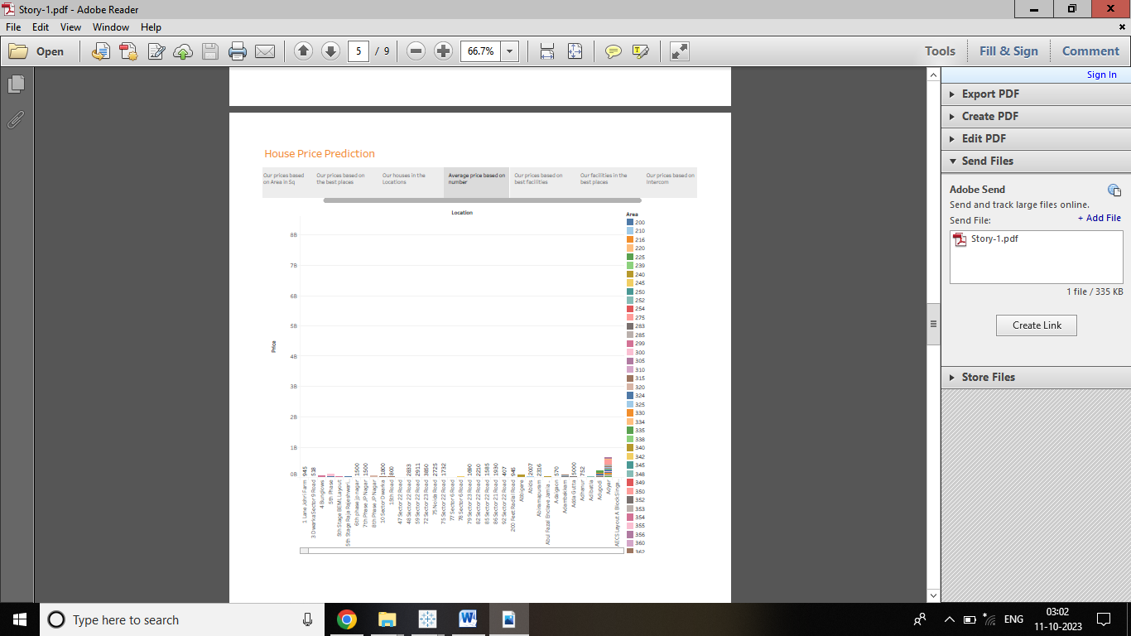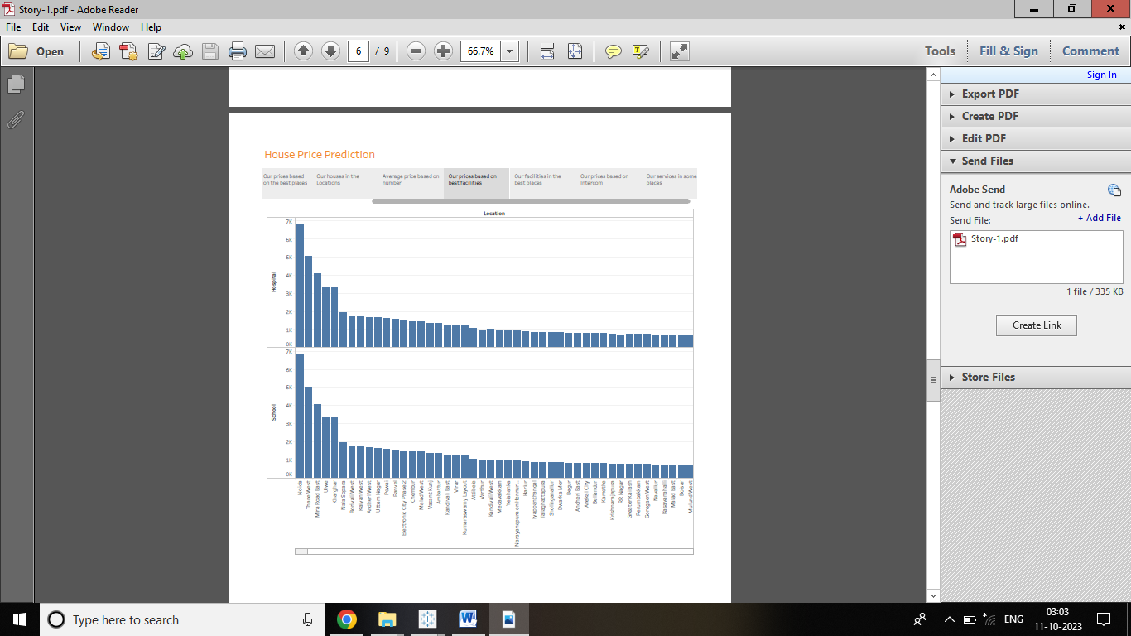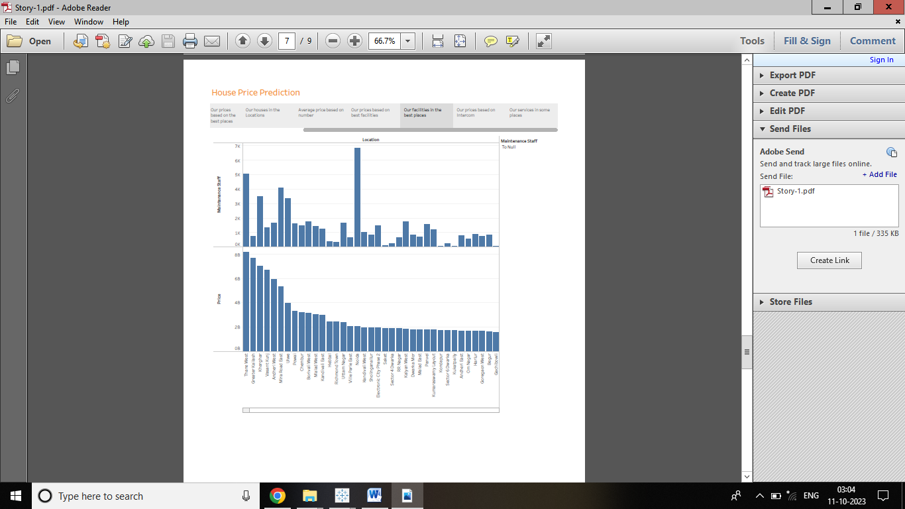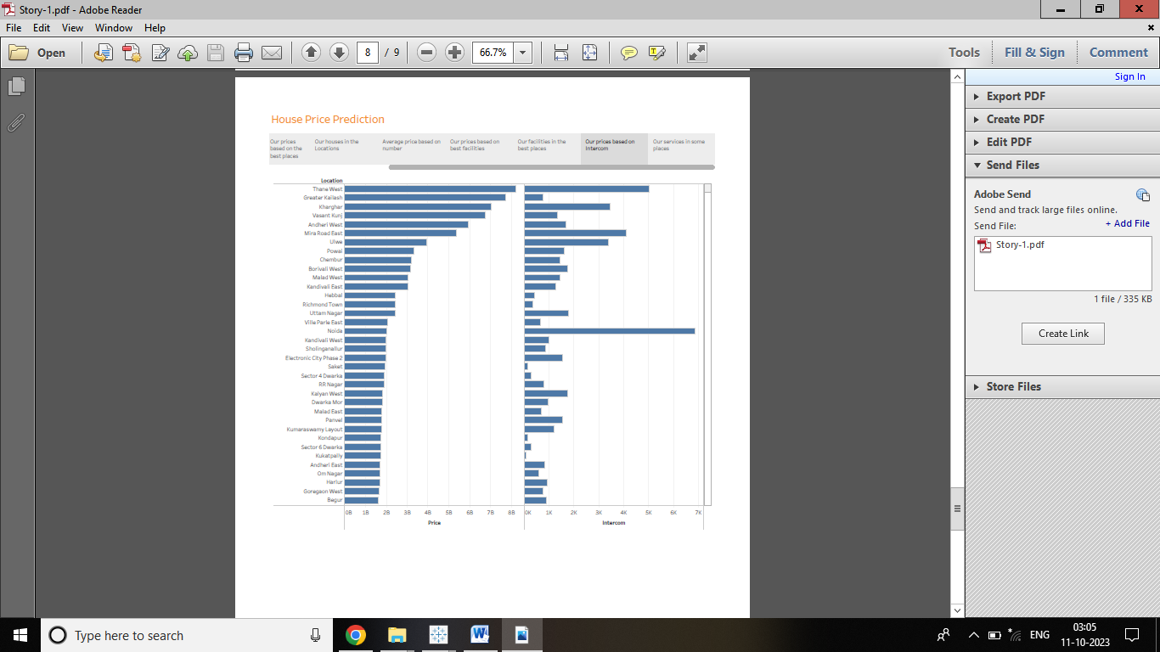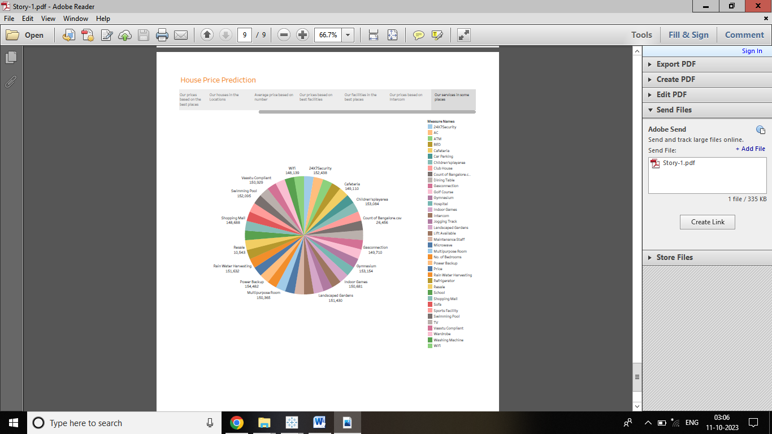

**Advantages & Disadvandages**

***Advantage:***

1.Informed Decision-Making: It helps individuals and investors make informed decisions when buying, selling, or renting properties, ensuring they get value for their investments.

2.Investment Opportunities: Identifying trends and potential hotspots can lead to profitable real estate investment.

3.Policy Formulation: Policymakers can use this data to develope housing policies that address affordability and sustainable urban development.

***Disadvantages:***

1.Data Quality: Inaccurate or incomplete data can lead to flawed analyses and unreliable predictions.

2.Data Availability: Access to comprehensive and up-to-data housing data can be limited, especially in emerging markets or certain localities.

3.Market Volatility: Real estate markets can be highly volatile, making it challenging to make precise long-term predictions.

**Applications**

1.Helping Homebuyers: Assisting people in choosing the right homes at fair prices.

2.Aiding Investors: Identifying good investment opportunities in real estate.

3.Urban Planning: Guiding city planners to develop infrastructure when it’s needed.

4.Government Policies: Formulating policies for affordable housing and sustainable cities.

5.Economic Insights: Proving insights into the health of the economy in these cities.

6.Reducing Risks: Managing risks in property transactions for professionals and banks.

7.Educational Research: Supporting researchers and educators in studying real estate trends.

**Conclusion**

In conclusion, analysing housing prices in big Indian cities is like having a roadmap for making wise decisions about buying homes, investing money, and planning how cities should grow. It’s a valuable tool for individuals, investors, government planners, and researchers to understand and navigate the complex world of real estate in metropolitan areas.

**Future Scope**

1.Better predictions: More accurate forecasts about future housing trends.

2.Smarter Investment: Easier identification of profitable real estate opportunities.

3.Improved Policies: More effective government policies for affordable housing and urban development.

4.Quick Decision-Making: Faster and more informed decisions for individuals and investors.

5.Data Accessibility: Increased access to housing data, making it easier for everyone to benefit.